Rural Advancement Fund and National Sharecroppers Fund -- Commemorating 80 years of Service to Family Farmers and Rural Communities

Excerpted (until 1986) from “Rural Advancement Fund Celebrates 50 Years of Farm Advocacy.” Robert Amberg; Vol. 9(5), 1987, pp. 11-15.

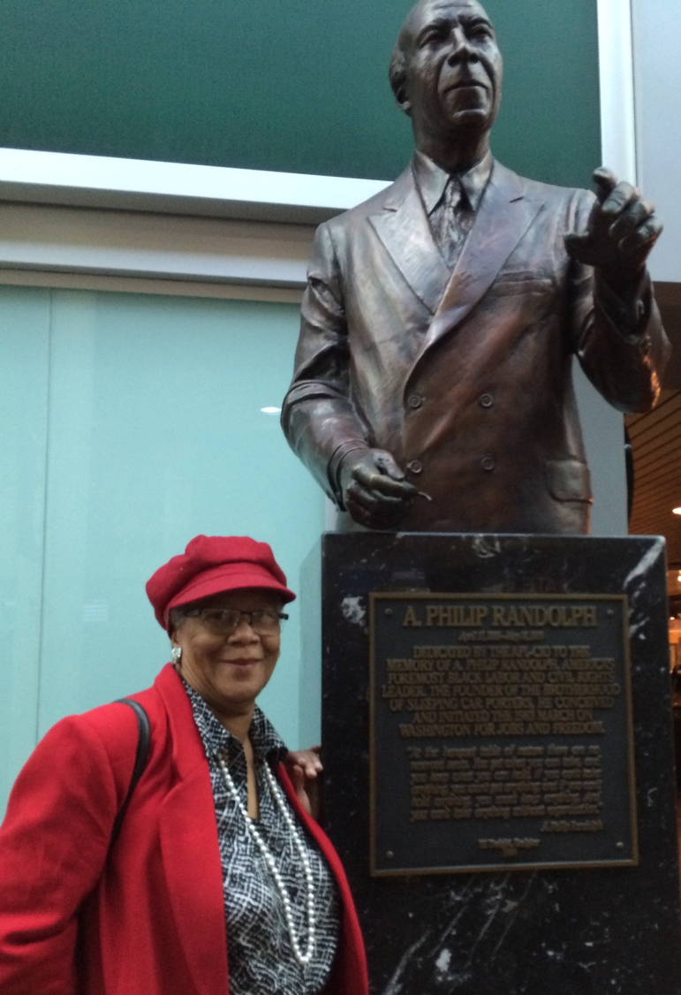
This year the Rural Advancement Fund/ National Sharecroppers Fund celebrates its eightieth anniversary as an advocate for family farms and rural communities. Initially formed as an annual "National Sharecroppers Week," co-sponsored by the Workers Defense League and the Southern Tenant Farmers Union, the formal organization began without a paid staff and served as the non-profit, funding arm for the fledgling Southern Tenant Farmers Union.
National Sharecroppers Week evolved into the National Sharecroppers Fund (NSF) in 1943 and in 1966 created the non-profit Rural Advancement Fund to receive donations from supporters. Through the years RAF/NSF has grown in both scope and influence to become an award-winning organization with an international program and a staff that continues to argue forcefully for the rights of small farmers around the world.
In 1937, NSF's focus was the South. While the nation as a whole was still mired in the depths of the Great Depression, the South and its predominantly rural population were faring worse than most. Agriculture was being revolutionized by mechanization, chemical fertilizers and pesticides, and big business, with the result that millions of sharecroppers, tenant farmers and farmworkers were displaced or forced to work for less-than-minimal pay. The estimated annual income for sharecropper families of the period was only $300, and the substandard living conditions contributed to diseases like pellagra, hookworm, syphilis and malaria. Educational opportunities for sharecroppers were nonexistent and the illiteracy rate was the highest of any occupational group in America.
Against this backdrop of misery and exploitation, eighteen men--black and white--met in July 1934, in a schoolhouse in Tyronza, Arkansas, to form the STFU. They were led by H. L. Mitchell [See Southern Changes, March 1987] and Clay East, admirers of Thomas. The union's goal was to work collectively for better working conditions and greater benefits for farmworkers hard hit by the labor-reducing Agricultural Adjustment Act of 1933.
While the goals seemed simple, the union had the weight of history and culture against it. The union was interracial when Jim Crow was still law. Further, STFU's constituency worked outside the typical industrial setting and often viewed themselves as independent producers. Finally, the union's leaders, Mitchell, East, J.R. Butler and Isaac Shaw were Southerners who had been heavily influenced by and eventually gravitated to socialism, the kind of socialism that had incubated in the immigrant ghettos of the urban Northeast and been practiced by many of this country's industrial labor unions.

By 1936 the union had a Southwide membership of over two thousand and a continual shortage of cash. In an effort to ease the cash crunch, Sidney Hertzberg, a young staff member of the Workers Defense League who had worked with STFU during the summer, came up with the idea of a National Sharecroppers Week. From 1937 to 1944, this educational and fundraising event was held annually in New York. The week of manuscript and print auctions, concerts and plays eventually included as sponsors such celebrities as Fiorello LaGuardia, John Steinbeck, Margaret Bourke-White, Eleanor Roosevelt, Upton Sinclair and A. Philip Randolph.
The changes in agriculture begun during the thirties had radically altered the lives of small farmers and farmworkers. Many abandoned their native South in search of industrial jobs in the North. Others, lucky enough to own land, stuck it out in the face of increasing competition from their better-equipped and better-financed neighbors. Still others, landless and without marketable skills, became a new class of farmworkers whose work was restricted to the planting and harvesting of crops. NSF chose to work with the last two groups--the small farmers who had opted to stay and the migrant farmworkers who had little choice.
- In 1950 NSF established the National Committee on Agricultural Life and Labor. NCALL pressured state and federal governments by distributing information and focusing the collective efforts of over forty individual organizations working with rural issues. The establishment of NCALL signaled a more direct role in politics for NSF and a recognition that the problems of farmworkers are sometimes solved away from the fields.

- NSF was guided in this period of transition and growth by Fay Bennett and Frank Porter Graham with active Board members including A. Philip Randolph. While NSF broadened its range of political activities, it continued funding like-minded organizations working directly with rural people.

- In 1953, NSF sponsored the formation of the Migrant Children's Fund, an organization devoted to addressing the health and educational needs of migrant families, and throughout the fifties NSF supported organizing efforts by the National Agricultural Workers Union (formerly STFU).
- In 1962, the year of NSF's 25th Anniversary, NSF sponsored the Bricks Conference, a three-day meeting on rural affairs which was widely attended by government officials, ministers, farmers and community leaders and represented another change in direction for NSF. In the past NSF had worked in opposition to most government agencies, but now, because of the influx of federal monies and FSF's reputation as an advocate for rural people, the organization was asked to work with government.

- NSF began work on the first of many contracts with the U.S. Department of Labor and the Office for Economic Opportunity. Offices were opened in Atlanta and Knoxville and programs implemented on illiteracy, job training and placement for displaced farm workers, the construction of self-help housing and the formation of rural cooperatives. With funds generated by NSF's new tax-exempt subsidiary, the Rural Advancement Fund (RAF), NSF set up day-care and education centers, housing programs and a rural credit union. A Washington office was opened during this period to increase NSF's lobbying efforts and to take better advantage of new federal programs.
- The late sixties and early seventies brought new internal changes to RAF/NSF with the departure of Fay Bennett and the death of Frank Porter Graham. Father A.J. McKnight was a board member, and current Federation of Southern Cooperative and Rural Coalition leaders John Zippert and Wendell Paris served as field representatives. RC Board member emeritus John Bloch served for a time as Washington, Representative.
- Jim Pierce, a labor and civil rights activist, took over as executive director and began building a rural demonstration and training center.
- The Graham Center, located in Anson County, N.C., opened in 1974 based on the idea that "creative approaches to the farm problem could make good and profitable use of marginal land and resources." THE GRAHAM CENTER'S free training program was aimed towards small farmers and their families and offered comprehensive training in all aspects of practical small farm operation and management. Courses in soil management, biological pest control, marketing, and crop and livestock production were supplemented by courses putting agriculture in a social and historical context. The Graham Center also housed a resource center which offered research and public speaking on rural, political and economic issues to church, university and farm groups.
- This fiscal and identity crisis precipitated the phasing out of training programs at the Graham Center in 1981 Kathryn Waller, executive director since the late 1970s, moved RAF/NSF back to its roots by instituting a traditional, grassroots organizing effort in the mold of STFU. Waller, along with program director Cary Fowler, instituted an international program to address Third World problems and the worldwide loss of plant genetic diversity.
- In 1977-78, RAF worked with other community based organizations to found the Rural Coalition to join diverse voices together to promote just and sustainable development in rural communities.
- Beginning in 1982, RAF sent representatives into the field in North Carolina and South Carolina. The goal was to organize farmers into a cohesive, multi-racial, farmer-led unit that could address issues affecting farmers and rural communities. During the mid to late 80’s, leaders including Mr. Billy Harvey and Mr. Leon Crump led organizing efforts.
- From the mid 1980’s, to the early 1990’s, Harvey annually brought a delegation of farmers to the Congressional Black Caucus meetings, where they raised vocally the growing concerns of African American Farmers and Ranchers. One of these farmers was Timothy Pigford, who became lead plaintiff of the Pigford v. Glickman Black Farmers Class Action lawsuit.
As RAF/NSF celebrates its eightieth year of service to family farmers and rural communities one appropriately recalls words from STFU's Ceremony of the Land:
"In man's greed for gold, he has destroyed the fruitfulness of the earth in his lust for power and dominion he has brought misery upon us all. The land cries out against those who waste it. Thy children cry out against those who abuse and oppress them. Speed now the day when the plains and the hills and all the wealth thereof shall be the people's own and free men shall not live as tenants of men on the earth

RAF Current Work

“Growing Farmers, Growing Food” Restoring Agriculture and Food Pathways in Orangeburg, SC

Georgia Good, RC Vice Chair
and Director, with Mr. William Booker, Rural Advancement Fund of the National Sharecroppers

Ms. Georgia Good, Director of the Rural Advancement Fund, co-presented with Mr. William Booker, RAF’s Farm Educator at RC’s 2017 Rural Development workshop. Ms. Good explained that “intergenerational reciprocity” or responding to the simultaneous need of kids to be engaged and of young farmers to be mentored is the foundation of “Growing Farmers” projects.
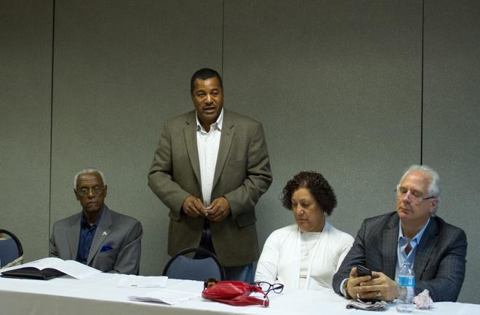
Mr. Willie Booker, Rural Advancement Fund, with Carol Zippert, and others in New Mexico in May 2017

Mr. Booker contextualized RAF’s emphasis on both the transfer of farming knowledge as well as the transfer of farmland to a new generation. The lack of available land is compounded by the shift to large industrial farming, and increasing corporate ownership. The historical recognized lack of access to credit for people of color, women and other marginal groups pushes farming further out of reach. RAF helps elders who own small farm holdings with “succession planning,” to enable the land to change hands. This requires clearing settling any prior heir-property issues and securing titles. He explained that RAF’s curriculum for young farmers is a “values based education,” teaching small vegetable production, money management skills, and the agricultural roots of their rural economy. He ended with a story illustrating the significance of RAF programs introducing children to the outdoors through farming. He described the amazement of a young boy, who went home with a soil-covered carrot in his pocket and a newfound knowledge of how things grow.

Ms. Good reminded everyone that growing farmers in one of the most impoverished communities in the US has a number of impacts well beyond increasing access to healthy food. Providing stipends for participating young farmers is integral to compounding these impacts. She concluded:

“this is how we envision food sovereignty.”

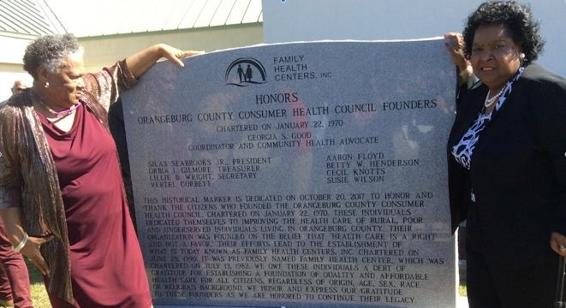

Also inducted into the SC Civil Rights Hall of Fame this year, Ms. Georgia Good is shown here with Ms. Betty Henderson. Both were recognized in October 2017 for founding the Orangeburg County Consumer Health Council and the first clinic serving the poor and people of color in Orangeburg, South Carolina.

RC Co-Chair Georgia Good receives “In the Spirit of Eleanor Roosevelt Award” at Winter Forum. R-With RAF delegation after presentation of 80 Year Award.

FEDERATION OF SOUTHERN COOPERATIVES/
A SHORT HISTORY

By: John Zippert, December 2017

I am adapting and updating this short history of the Federation/LAF, which I wrote a few years ago on the occasion of the Rural Coalition’s Annual Winter Conference to celebrate the 80th anniversary of the National Sharecroppers/Rural Advancement Fund, the 50th anniversary of the Federation/LAF and the impending 40th anniversary of the Rural Coalition and the Farmworkers Association of Florida, coming in 2018.

From a historical perspective, it is important to note some of the common threads of our history as organizations. The Federation and the National Sharecroppers Fund share a similar constituency of small farmers, tenant farmers and workers on the land. We also share a history that grew out of the Southern Tenant Farmers Union (STFU) that was active in the 1920 and 1930’s in fighting for fair wages for farm labor in the cotton fields and plantations of the South and across America. The STFU itself grew out of the Populist Movements of the 1880’s and 1890’s. Many of these prior efforts suffered from racist pressures on Black and White worker solidarity.

One of the first trips I took out of Louisiana in 1966 was to visit Jack Wasserman, in the Atlanta office of the National Sharecroppers Fund, to seek advice and assistance in organizing farmers’ cooperatives in Louisiana. The Federation worked closely with the National Sharecroppers Fund, especially in Georgia and the Carolinas.

Also in the late 1960’s, I visited with H. L. Mitchell. President of the Southern Tenants Farmers Union, who was organizing sugar cane workers in southeast Louisiana. During those visits, H. L. Mitchell explained some of the difficult history of the STFU. He introduced me to Frank Lapeyrolerie, who was organizing a credit union in Reserve, Louisiana, embracing sugar cane workers and other rural people. Later Lapeyrolerie came to the founding meeting of the Federation of Southern Cooperatives and was a signatory of the charter.

I joined the Board of Directors of the Rural Coalition in 1976 to represent the Federation and grassroots organizations in the formulation of national rural policy, particularly as it impacts family farmers, Black farmers and farmworkers.

The Federation of Southern Cooperatives/ Land Assistance Fund is a non-profit, tax exempt, service, resource and advocacy association, involving 20,000 low income rural families, organized into more than 75 cooperatives, credit unions and community based economic development groups across the South.

Founded in 1967, by cooperatives and credit unions organized by civil rights movement, the Federation/LAF has over fifty (50) years of direct, first-hand and cutting-edge experience working with rural poor people and their families. The Federation is working with people in economically distressed areas who are trying to help themselves end the cycle of poverty in which they find themselves. In many ways, the Federation/LAF can be viewed as continuing the work of the work and spirit of the civil rights movement in the realm of economic and social justice for farmers, farmworkers and other rural poor people.

In 1985, the Federation merged with the Emergency Land Fund, whose mission was to work to stem the loss of Black owned land and farmers’ in the South and the nation. Since our missions overlapped in many areas and we work with the same or similar constituents, we were able to successfully merge and work together.

The Federation/LAF is governed by an 11-person Board of Directors democratically elected by our membership. Chartered to operate in the District of Columbia and 15 Southern and border states, our work is concentrated in Mississippi, Alabama, Georgia, Louisiana and South Carolina. The organization has offices in: Epes, Alabama; Atlanta and Albany, Georgia; Jackson, Mississippi; and Columbia, South Carolina, to serve our membership. Volunteer board members and community contacts provide assistance in other southern states.

Our membership includes 10,000 Black farm families, who own over half a million acres of land and work through 35 agricultural cooperatives to purchase supplies, provide technical assistance and market their crops together; 12,000 small savers, in 15 community development credit unions have over $20 million in assets and have made over $ 100 million in loans since their inception. We also work with handicraft producers, fishermen, consumers, people who need affordable housing and other rural residents interested in developing self-help cooperative solutions to their problems.

There are four major themes of the Federation’s mission, work and accomplishments over the past five decades. Our performance in these areas is key to evaluating our success and strength over this sustained period. The central themes of our mission are:

* to develop cooperatives and credit unions as a means for people to enhance the quality of their lives and improve their communities;

* to save, protect and expand the landholdings of Black family farmers in the South;

*to develop a unique and effective Rural Training and Research Center to provide information, skills and awareness, in a cultural context, to help our members and constituents to build strong rural communities

* to develop, advocate and support public policies to benefit our membership of Black and other family farmers; and the low income rural communities where they live;

The Federation has woven these themes together to create a strong community based movement of organizations steeped in struggle, tested by time, experienced in fighting exploitation, with a knowledge of the tactics, tools and techniques needed to help people build their own prosperity and progress. In many cases, the Federation works in conjunction with national policy organizations like the Rural Coalition, National Family Farm Coalition and the National Cooperative Business Association, to implement its policy change priorities and agenda.

Our major concerns lie in the area of rural development, and more particularly in the problems of Black and other farm families of color in retaining their land and sustaining a productive way of life in rural America. It is a well-documented trend in the South and rural America generally, that Blacks and other people of color are losing their land at a faster rate than white farmers.

In 1920, Black people owned over 15 million acres in the South; by 1960, this had declined to 100,000 Black farmers owning less than 6 million acres; by 1980, there were only 57,000 Blacks owning less than 4 million acres; now according to the 2012 Agricultural Census, there are less than 30,000 Black farm families remaining with less than 2.3 million acres. Preserving the land base of African-American family farmers in the South and helping them to use it in a productive, collaborative and sustainable manner is our program priority.

The Federation/LAF owns and operates a Rural Training and Research Center on 850 acres of land near Epes, Alabama, in Sumter County where we teach our members farming skills, rural business development, leadership development, and ways of working together in cooperatives and credit unions. Recently, the FSC Rural Training Center has become the site of a Federal-state forestry initiative and demonstration for Black family farmers with woodlots and timber resources.

Over the years, the Federation/LAF has provided services, learning and leadership experiences, saved family estates, reduced costs, increased revenues and enhanced stability for members (through producer, marketing, consumer and credit cooperatives), taught techniques and skills all of incalculable worth. A beginning estimate of the additional monetary impact of the Federation/LAF for the past 50 years is over $300 million. This includes:

•$75 million in sales through cooperative marketing;

•$25 million of member shares saved in credit union accounts and 50,154 loans totaling $97.5 million loaned to low income families;

•$26 million worth of housing units constructed and rehabilitated;

•$50 million mobilized in resources for support of member cooperatives and credit unions;

•$87.5 million worth of land saved and retained.

Beyond these direct and tangible impacts are the intangible benefits of the Federation’s work in terms of the leadership growth of people, the changes in people’s behavior that make collective decision making more effective, a greater appreciation of sharing by people as a means of working together economically in communities. One of our greatest accomplishments has been in helping to teach groups of people in co-ops how to make decisions about their collective wellbeing and lifting up the communities where they live.

The Federation works primarily in rural counties that are distressed with the grassroots people who are there. In the Black Belt region of the South, these counties are disproportionately populated by Black people, poor people, families headed by single females and children, including many foster children, living in poverty conditions.

Many of these persistently poor rural counties have experienced double digit unemployment and poverty rates for decades coupled with very low median family incomes, well below state and national standards. The condition of these counties is a reflection of racist political decisions coupled with a self-induced cycle of poverty where peoples’ lack of adequate nutrition, education, and housing feeds upon itself creating greater and greater levels of hopelessness and despair.

The Federation works directly with people in these communities and takes them through a process, involving:

-organizing: getting people with similar problems and needs to meet together;

-education: six months or more of analyzing community needs and examining the cooperative principles and practices as a means of tackling the problems;

-savings: pooling funds and resources towards developing a
cooperative business solution to the problem, linking the education and saving phase together;

- action: the actual implementation of the cooperative or credit union project, with continuous education and pooling of resources.

The people organizing the cooperative are the initiators and drivers of this process. The Federation provides community organizing and technical advice to the perspective community groups but the decisions and progressive steps are up to the group. The Federation works with the local people selected by the group to develop the board of directors, management and leadership of the cooperative, credit union or community development organization. The Federation continues to interact and work with these leaders over time as the cooperative business is implemented and grows.

More information on the history, work and programs Federation/LAF is available on our website: www.federation.coop.

FEDERATION OF SOUTHERN COOPERATIVES/
LAND ASSISTANCE FUND
Website: www.federation.coop

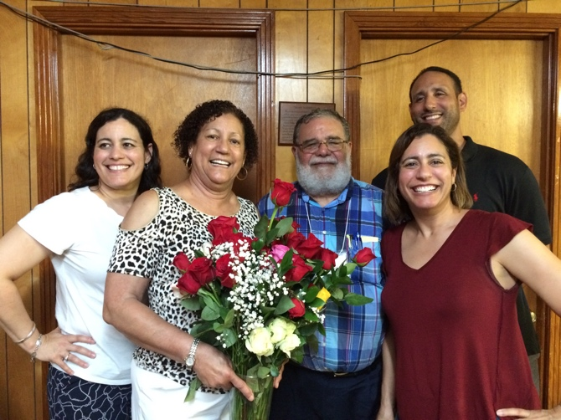

The Zippert's celebrate their 50th Anniversary with their children.

One Day We Created A New Family

One day when we needed
new birth to help us discover
our history, live our culture
and pursue our justice,
we created a new family.

One day when we needed
to reclaim our dignity and respect,
when we needed to lift our heads
and open our eyes and minds,
we created a new family.

One day when we needed
to find our sisters and brothers
in struggle and form a bond
for our mutual survival,
we created a new family.

One day when we needed
to save our children
to extend their lives and learnings,
when we needed to prepare them
as community-directed leaders,
we created a new family.

One day when we needed
to rediscover God’s earth
and all its gifts, to appreciate the soil,
waters, all living creatures and resources,
we created a new family.

One day when we needed
to save our land, build our houses,
provide for our healthcare,
secure our right to vote,
and assert our political leadership,
we created a new family.

One day when we needed
to form a more responsive society,
when we needed to secure more
loving communities,
we created a new family.

One day when we needed
a new family
for ourselves and for our children,
for our communities and for our nation,
One day when we needed
to celebrate God’s world
we created a new family,
We created the Federation -
the FSC Family.

One day we needed
a new family

Carol Prejean Zippert

Honoring Three Decades of the National Family Farm Coalition

National Family Farm Coalition (NFFC) was established in 1986 as a national voice for family farmers who demanded fairness and justice in the midst of the 1980’s farm crisis. Headlines chronicling the unfair farm foreclosures which hundreds of family farms across the rural landscape faced coincided with stories of suicides and loss. At that time, they realized that having a seat at the table in Washington, DC, was mandatory to achieve immediate relief from an unjust system inclined to put the interest of family farmers behind that of corporate farm operations.

NFFC opened an office on Capitol Hill in 1986 with initial funding from Farm Aid and support from the Federation of Southern Cooperatives and many others. For more than three decades, Kathy’s guidance established NFFC as a major policy advocacy force in Washington, DC. NFFC’s presence has provided an effective clarion call for justice, and in 1987 the organization lead the way for reform that brought relief to farm families through the enactment and implementation of the 1987 Agricultural Credit Act. The legislation enabled an estimated 70,000 farmers, many facing foreclosure, to refinance their debt and remain on their land. With the Farmers Legal Action Group (FLAG), NFFC conducted training sessions for farm leaders and advocates and provided tools to assist farmers with credit problems. NFFC later worked with Rural Coalition, the Federation of Southern Cooperatives and other organizations to pass the 1990 Minority Farmers Rights Act, and has since lobbied for full funding for Section 2501 to support outreach, education, and lending programs for minority farmers.
In the ensuing years, the combination of NFFC's member groups’ grassroots strength and experience working on national policy has enabled it to play a unique role in advocating for an environmentally sustainable, economically just, healthy, safe and secure food and farm system. Additional power has come from collaborative work with a carefully built network of domestic and international organizations that share similar goals.

NFFC has long been a leader on many important issues facing farm, fishing, and rural communities, and has taken many stands that place it at odds with large farm and commodity groups claiming to represent family farmers. The Coalition was an early opponent of genetically modified crops and animals—primarily for means through which the technology has shifted control of seed ownership, breeding, and distribution from farmers to corporations—and has fought their inclusion in the food system since the introduction of bovine growth hormone (rGBH) in the mid 1990s. NFFC has supported family dairy farmers for decades, including participation in an important lawsuit against Dairy Farmers of America; today it is nearly the only organization keeping the dream of family-owned dairies alive. NFFC has long been the primary family farm voice in the fight for fair trade policy in the US and internationally, including though membership in the international peasant movement, La Via Campesina. The Coalition has also been an active supporter of implementation and enforcement of the Farmer Fair Practice (GIPSA) Rules; broad agricultural antitrust enforcement; country of origin labeling for meat; checkoff reform; and much more.

NFFC was a cofounder of the Community Food Security Coalition, the US Working Group on the Food Crisis, and US Food Sovereignty Alliance, and has been part of many informal and ongoing collaborations and partnerships, often as the only family farm representative. The films King Corn, FRESH, Food, Inc., and The Last Crop, and books The Omnivore's Dilemma, Foodopoly, Farm Together Now, and Food Voices, were influenced by and include NFFC leaders.

Friends of Rural Coalition will know that Executive Director Kathy Ozer passed away in January 2017, from complications of non-Hodgkin's lymphoma. It has been a year of mourning, regrouping, visioning, and recommitting to members and the ongoing struggles under the able interim leadership of Lisa Griffith.

In addition to the search for a new executive director, NFFC is focused currently on the 2018 farm bill; legislative redress for the tens of thousands of farmers whose crops were damaged by dicamba drift this season; exposing TIAA’s use of educator pension funds to grab US and foreign farm land for exploitation; raising awareness of the ongoing price crisis for family farmers, particularly dairy, poultry and livestock farmers; securing equitable credit access for all (especially minority) farmers; and fighting for fairness for rural communities in today’s tsunami of regressive trade, tax, environmental, and spending legislation.

NFFC’s grassroots member organizations today still represent family farmers and ranchers, community-based fishermen, and rural advocates who fundamentally believe in the concept of food sovereignty. The Coalition works to elevate their concerns, solutions, and experiences every day.

Rural Coalition Statement Honoring Kathy Ozer, Our Beloved Sister
It is with deep sadness that we learned the news from our sister organization, @National Family Farm Coalition. Our beloved sister Kathy Ozer has departed this earth. As one who has stood with all our communities for many years of dedicated and indefatigable service, uplifting and uniting all our communities, she leaves a huge void.

We have worked with Kathy since she joined NFFC three decades ago to confront the farm credit crisis in the late 1980’s with the advocates supported by Farm Aid. And we worked with her on every major piece of farm and food and trade legislation since. When NFFC reached out to include the North American Marine Alliance, our diverse family of farmers and ranchers, farmworkers, and now fishers grew to become more united in pursuit of equity and food sovereignty.

In this work of justice, relationships and cooperative action mean everything. Kathy worked for many years with a generous spirit to connect everyone and bring to the table (and feed, nourish and house) the voices who needed to be there. Her grace, wisdom and hospitality – and laughter - will be sorely missed.

Our hearts will not be discouraged as we stand with our sisters and brothers of NFFC, her husband David Battey, and her family to honor her amazing life. We are assured, as NFFC reflected that her spirit will surround and inspire us as she embarks on a new journey. She is still uniting us. Godspeed, our dear Sister till we meet again. The great beyond has once more gotten greater.
The Board and Staff of the Rural Coalition
January 23, 2017

California Institute of Rural Studies –Serving California Rural and Farmworker Communities for 40 Years
Preparing for its 40th anniversary this year, the California Institute of Rural Studies returned as a Rural Coalition member in 2016. They had been members in the earlier days of the organization.

Gail Wadsworth, Executive Director since 2009, recently shared some CIRS history, highlights of their current work, and reflections about what membership in Rural Coalition has brought to their recent work.
CIRS researches issues that impact marginalized members of rural communities in California. In particular they conduct research that can be used to drive advocacy and change while increasing the visibility and voice of small, marginal and forgotten rural communities.

For a recent event at the Salton Sea in the Coachella Valley, CIRS was informed by several partners that there were too many meetings and discussions going on and that local residents, primarily Spanish and Purepecha speakers, were left out of these conversations.

“We were concerned that we would not be able to get local residents to attend and speak freely and powerfully in that space with those who are normally considered powerful. Learning from RuralCo, we designed the event to shift the power in the room so that residents held the space, time and power. I made sure that they were heard, without the fear of being ignored or cut off.

We made space for questions and comments to agency personnel, academics and nonprofit leaders. The opening panel of residents told stories and these stories were powerful -- impacting all listening. I learned from RC that you attend to the power dynamic and who needs to be heard and you design the space for that. We made sure that the Purepecha women in the room could speak in their own language and be heard by all.” To get full participation of local residents, CIRS called on RuralCo partner, Lideres Campesinas to help get the word out and make sure residents understood that this space was for them to voice their experiences and hopes for the failing Salton Sea. In addition, reservations were made using an online platform and CIRS was aware that many residents do not have access to the internet. Lideres Campesinas took the request seriously and reached out to and registered so many residents that the meeting room exceeded capacity. “We never would have succeeded in getting those very powerful voices into that space without our partners at Lideres Campesinas, special thanks to organizer Manuela Ramirez for the amazing work!”

We can’t do research in isolation. Our reason for being is to spur action and advocacy based on research data. We embrace the value of all kinds of data and have launched a story-telling project to inform and motivate listeners. We learned from RuralCo that it is important to structure time to allow for diversions and unexpected stories that arise and add value to all meetings.

Citation.

